- Evidence (label each clearly)
  - AES encrypt/decrypt with the MATCH confirmation (Task 1).
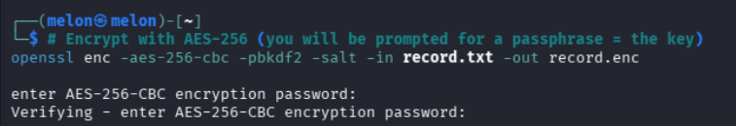
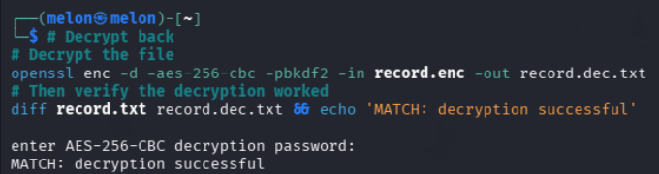

  - RSA signature verify output showing ‘Verified OK’ (Task 2).
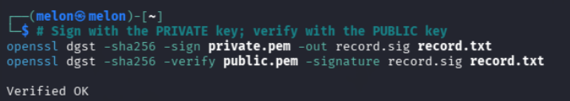

  - The curl -k https://… output over TLS (Task 3).
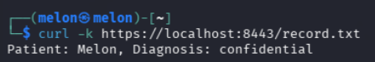

  - The KMS KeyId(s) and the envelope-encryption steps (Tasks 4–5).
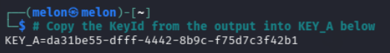
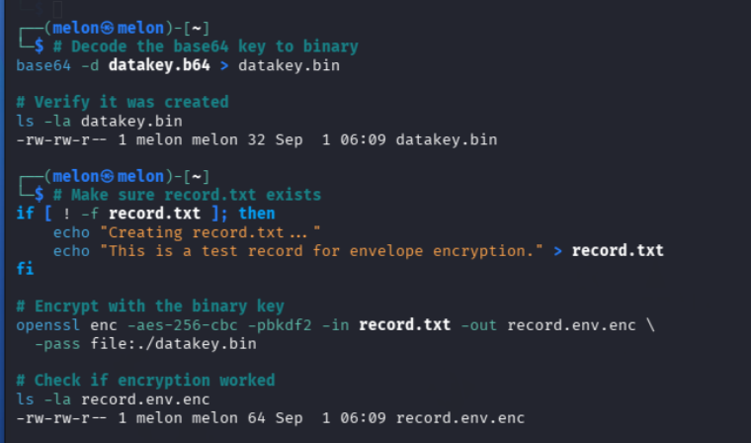

  - The failed kms decrypt after key erasure (Task 6).
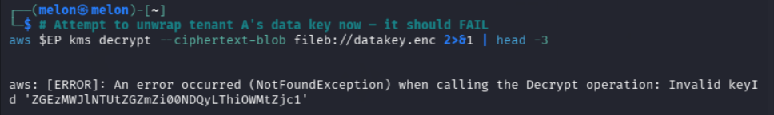

  - The two differing SHA-256 hashes and the hash chain (Task 7).
